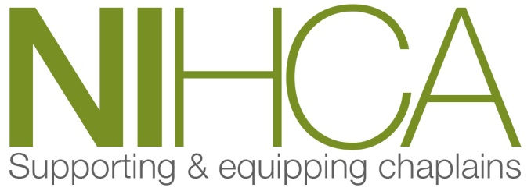

chaplains@nihca.co.uk www.nihca.co.uk

Training Programme 2021/22

Date | Venue | Topics
2021
September – November 2021 | Ballyclare | CPE – Clinical and Pastoral Education  Unit with Sr Mary Jo Corcoran
Wed 13th  9.30am - 5.00pm  -  Thurs 14th Oct  9.30am - 4.00pm | Dromantine Retreat &  Conference Centre,  Newry | Changes in Legislation on Abortion and the right of Conscientious Objection – Karen Murray RCM  Retreat – Reflection on emerging from the Pandemic – Bishop Router
Wed 24th Nov  9.30am - 4.00pm | Pandemic & Innovation in Chaplaincy and Bereavement Support | Multidisciplinary Training Day
Tuesday 9th December | ZOOM-in-Hour | T/B/A
2022
Wed 26th Jan  9.30am - 4.00pm | Pandemic & Innovation in Chaplaincy and Bereavement Support | Multidisciplinary Training Day
Tuesday 8th February | ZOOM-in-Hour | T/B/A
Wed 2nd  9.30am - 5.00pm  -  Thurs 3rd Mar  9.30am - 4.00pm | Dromantine Retreat & Conference Centre, Newry | Professional Qualification  in Reflective Practice  with Prof Ewan Kelly and Colleague  (Must attend complete  Two-day course to qualify)
Wed 25th May | To be confirmed | AGM

Director of Training:

Rev Norman Harrison BD, Cert CPC, CPE(1), MMin, ILM5, PG Cert (Healthcare Chaplaincy)

