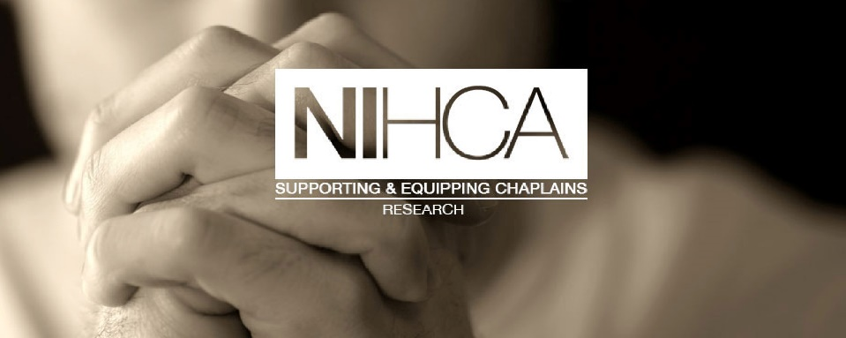
NIHCA Research Network
Workshop on 27th April 0930 – 1430
Venue – The Crescent Church, University Road, Belfast.

How to get into print, writing for success
Conference presentations -hints and tips

Facilitated by Reverend Dr Daniel Nuzum

PROGRAMME
0900 Welcome
0930 – 1100 Session One: Writing successfully
1100-1120 Coffee break
1120-1250 Session Two: Conference Presentations
1250 – 1330 Lunch
1330- 1430 Reflections and questions
1430 Close and tea

This Workshop will be interactive and all Healthcare Chaplains are really welcome. For those who can, do bring work in progress that you need help with.

Daniel Nuzum MTh PhD
Daniel Nuzum is a healthcare chaplain, Clinical Pastoral Education supervisor & educator, an Anglican priest and a practical theologian specialising in perinatal and palliative care ministry at Cork University Hospital and Marymount University Hospital and Hospice, Cork. Daniel received his PhD from University College Cork in 2016 where his thesis was ‘The spiritual and professional impact of stillbirth’. Daniel is an active member of the Pregnancy Loss Research Group at University College Cork and an adjunct lecturer in the College of Medicine and Health, University College Cork. Daniel is an editor of the journal Health & Social Care Chaplaincy and is a published author in peer reviewed journals and a number of healthcare chaplaincy books.
Daniel’s research interests are in the area of ministry following stillbirth and neonatal bereavement, spirituality in specialist palliative care, pastoral education and practical theology.

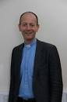

RSVP by 20th April
To: research@nihca.co.uk
Please indicate any dietary requirements you have as lunch will be provided. If you need to cancel your attendance, can you e-mail by 23rd April.

