Three Chaplains go to ERICH …
better than one man went to Mo - we think so!

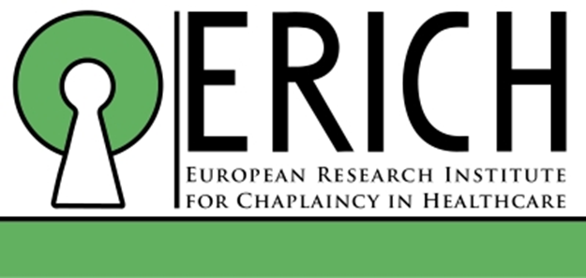

ERICH stands for European Research Institute for Health Care Chaplaincy and was launched on 6th June in Leuven, Belgium. Three NIHCA Chaplains attended a two day Conference 6-7 June. Rev Don Gamble (Lead Chaplain, SE Trust), Rev Ken Connor (Chaplain, SE Trust) and Rev Rosie Morton (Chaplain, Belfast Trust). The European Network of Health Care Chaplains has members from 32 Nationalities, mostly European countries but also Israel, Iceland, Norway, Sweden, Russia. At a European Health Care Chaplaincy Network Conference in 2016 the need to focus on research for and by Chaplains was identified as a priority, which is how ERICH was born!

Day one - Tuesday 6th June, a Conference day with both oral and poster presentations.
Day two – Wednesday 7th June, a Master Class.

Here are just some highlights:

- Professor Dr Anne Vandenhoeck who is Director of ERICH and Chair of the Academic Centre for Practical Theology at KU Leuven presented a paper ‘Why does research matter?’

Research matters for there to be Chaplaincy in existence in the future. It is a challenge throughout Europe that with rising costs of health care and increasing secularisation, the need for chaplains is being questioned and Chaplaincy is often seen as a soft target to cut back on. Anne reported on an innovative way that Health Care managers and Flemish Government Politicians were shown the value of Health Care Chaplains. A 6 minute film was made about Chaplaincy in a mental health hospital. Anne suggested that European wide research is needed as individual European countries can be parochial. By countries collaborating the research is strengthened and ERICH exists to help make this dream happen. ERICH is being funded by benefactors who wish to remain anonymous and the John Templeton Foundation.

- Professor Dr Christina Puchalski, Director of the George Washington Institute for Spirituality and Health presented a Paper entitled ‘Medical perspective on the value of spiritual care and chaplaincy in health care’

Christina is a medical Doctor with a passion for combining good medicine with good spiritual care. She spoke about how she has introduced ‘reflection rounds’ to her medical ward rounds. Her rationale is that the inner life and humanity of the Health-Care professional does have an impact on how illness is perceived and the relationship with the patient. She is interested in how patients affect Doctors and is keen for Doctors to become more aware of this in their day to day practice. Time is given after ward rounds to reflect on modified verbatims.

- Reverend Dr Daniel Nuzum - Health-Care Chaplain, Cork University Hospital, CPE Supervisor and Secretary of Chaplaincy Accreditation Board presented a Paper ‘The spiritual and professional impact of stillbirth’

This is Doctorate research undertaken by Daniel with a small sample of women. The method chosen to analyse data from interviews was phenomenology. Dr Nuzum’s enthusiasm for this area of research is inspired by the stark fact that for every perinatal bereavement there is a life-long impact on the family affected.

- Professor Dr Austyn Snowden (Lead Researcher for ERICH and Edinburgh Napier University) and Professor Dr Ewan Kelly (Research Co-ordination, ERICH) presented a Paper on ‘Patient Related Outcome Measure (PROM)’

ERICH will fund 6 European Countries to pilot PROM over a three year period. A Chaplain recruits a patient who fills in a form which is sent to KU University, Leuven for analysis. This is an objective way patient views of Chaplaincy can be obtained. In addition, the economic impact of Chaplaincy is also being studied to be able to identify the cost effectiveness of Chaplaincy. There are to be two two pilot sites in Ireland – Cork University Hospital and SE Trust, Belfast.

- Master-class on Case Study as a Research Method
Facilitated by Professor George Fritchett who is Director of Research at the Dept of Religion, Health and Human Values, Ruth University Medical Centre, Chicago.
And Steve Nolan who is a Palliative Care Chaplain at Princess Alice Hospice, Surrey whose Doctoral research is ‘Spiritual Care at the end of life’

Three reasons were given for why Case Studies matter for Health Care Chaplains:
- A single, descriptive case study can contribute to research
- Case Studies are already part of Chaplaincy education, for example in Clinical Pastoral Education (CPE)
- Multiple Case Studies can lead to research trials and inform best practice

Case Studies really apply to Chaplains in Health care as it reflects how Chaplains work day to day as encounters with patients are one to one. Importantly, Case Studies include the perspective of the Chaplain and the patient for example by including verbatims or records of conversations. Case Studies as a research tool can include patients (short or long stay in health care facilities), staff and relatives.

More information on ‘how to do’ a case study refer to -
Edited by George Fritchett and Steve Nolan ‘Spiritual Care in Practice’, Jessica Kingsley Publishers, 2015

Is the LOGO for ERICH a puzzle?!
is it a lock or a person with a halo? How do you see it?

A lock symbolises research as progressing knowledge and unlocking innovation and development
A person with a halo - symbolises the uniqueness of each person which is at the heart of Health Care Chaplaincy

If you are keen to find out more go to the ERICH web-site which has videos of the day.
www.chaplaincyresearch.eu

And FINALLY great to go off to Conferences ….
but how will this Conference impact on Ken, Rosie and Don?

- Ken is keen to learn more about community Chaplaincy and PROM
- Don is keen for SE Trust to be a pilot site for PROM
- Rosie is keen to publish on hope from a Study Day she facilitated

By the end of this Conference we were all energized, enthused and exhausted, but we look forward to the next Conference!

