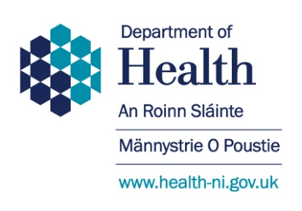

COVID-19 QUESTIONNAIRE
Question |  | Answer (please delete as appropriate)
1 | Name of Trust/Hospice where you work
2 | Are you employed or voluntary? | Employed / Voluntary
3 | How many hours do you work weekly? | 1-8 / 9-16 / 17-24 / 25-32 / 33+
4 | What is your age bracket? | 20+ / 30+ / 40+ / 50+ / 60+ / 70+
5 | During this pandemic, have you been at home shielding, self-isolating, working from home and/or still attending the hospital/hospice? | Shielding / Self-isolating / Working from home / Still attending
6 | Did you show any symptoms of COVID-19? | Yes / No
 | If ‘yes’, have you been tested? | Yes / No
7 | If you were shielding, self-isolating and/or working from home, in what ways were you able to reach out?
 | - Answering phone calls | Yes / No
 | - Preparing resources | Yes / No
 | - Keeping in contact with other chaplaincy colleagues and staff | Yes / No
 | - Other…
8 | Did you have any requests for chaplaincy support? | Mid-March to April |  | May
 |  | Yes / No |  | Yes / No
 | - How many patients have you been asked to see (approx.)?
 | - How many staff have you given support to (approx.)?
 | - How many relatives have you communicated with in-person or virtual means (approx.)?
9 | While at home, did you receive any communication from the Service Management enquiring about your well-being? | Yes / No
 | If ‘yes’, by what means?
 | What did you find helpful?
10 | During this period, has your Church authority/belief group enquired about your well-being? | Yes / No
 | If so, by what means?
 | What did you find helpful?
11 | During this time have you been asked to assist other departments? | Yes / No
 | If so, which departments?
 | What assistance were you able to give?
12 | During this pandemic, have you been involved in any multidisciplinary groups, e.g. Staff support, Ethics Committee, Bereavement support, etc.? | Yes / No
 | If ‘yes’, which ones and what was your role?
13 | Have you been trained in the use of Personal Protective Equipment (PPE)? | Yes / No
14 | Have you been fit-tested for a respiratory mask? | Yes / No
15 | Had you any contact with COVID-19 positive patients? | Yes / No
 | If ‘Yes’, how many (approx.)? | Mid-March to April | May
16 | Where you asked to attend a patient in an Intensive Care or Critical Care Unit using full PPE? | Yes / No
 | If so, on how many occasions (approx.)?
17 | Were you on a referral-only basis or did you continue routine pastoral work?
18 | Did you feel you had appropriate PPE at all times? | Yes / No
 | Had you any concerns about PPE use?
19 | Were you concerned about your general well-being while attending patients in the hospital? | Yes / No
 | If so, what were your principal concerns and why?
20 | Did you receive guidance either from NIHCA and/or Service Management about chaplaincy during this time? | Yes / No
 | If ‘Yes’, by what means?
 | Is there anything else you feel could have helped you?
21 | What innovations within chaplaincy have you introduced, and what have you learned that could be shared with others to help future practice? (Max. 250 words)

