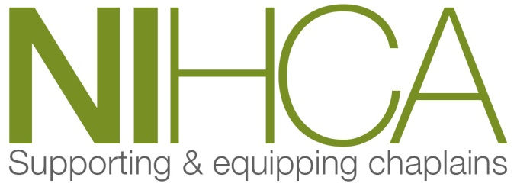

trainingdirector@nihca.co.uk www.nihca.co.uk

Training Programme 2019/20

Date | Venue | Topics
2019
Wed 29th May  9.30am - 2.00pm | Project Echo Hub  1 Shore Road, Belfast | Rev Prof Max Watson  “Project Echo” & AGM
Wed 9th  9.30am - 5.00pm  -  Thurs 10th Oct  9.30am - 4.00pm | Drumalis Retreat &  Conference Centre,  Larne | Rt Rev Bishop Ken Clarke  Spiritual and Theological Reflection  on the theme of  “The Shepherd Psalm 23”
Mon 25th Nov  9.30am - 4.00pm  Date t.b.c. | Belfast Trust | Multidisciplinary Training Day  Rev Steve Nolan – Hopeful Presence at the End of Life
2020
Mon 27th Jan  9.30am- 4.00pm Date t.b.c. | Western Trust | Multidisciplinary Training Day  Rev Steve Nolan – Hopeful Presence at the End of Life
Wed 4th  9.30am - 5.00pm  -  Thurs 5th Mar  9.30am - 4.00pm | Dromantine Retreat & Conference Centre, Newry | SWAN Nurses (Manchester)  Fiona Murphy & Alice Davies  A palliative pathway “A Good Death”
To be confirmed | To be confirmed | CPE
Wed.27th May 2020 | To be confirmed | AGM

Director of Training:
Rev Norman Harrison BD MMin

