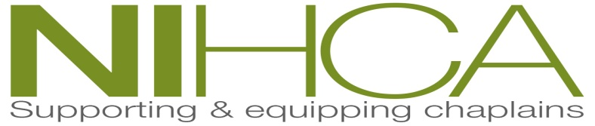

Northern Ireland Healthcare Chaplains’ Association

ANNUAL REPORT
2018/2019

President – Sister Mary Jo Corcoran

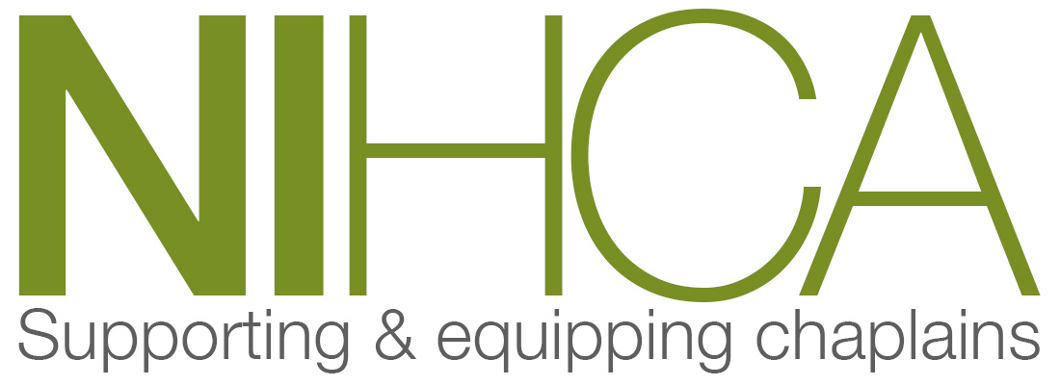

Contents
Page 3 Executive Council Information – April 2019
Page 4 Report from the President (Sister Mary Jo Corcoran)
Page 7 Report from the Secretary (Alannah O’Neill)
Page 9 Report from Director of Training (Rev Norman Harrison)

NIHCA Executive Council 2018/19

PRESIDENT Sr. Mary Jo Corcoran (retires May 2019)

VICE-PRESIDENTS The Revd Don Gamble (CoI - 2017)
The Revd Derek Johnston (Meth - 2017)
The Revd John Gilkinson (Presb - 2018)
The Revd Robert Sloan (RC - 2017)
Mrs Carolyn Patterson (OD - 2017)

SECRETARY Mrs Alannah O'Neill (retires May 2019)

DIRECTOR OF TRAINING The Revd Norman Harrison (2018)

TREASURER The Revd Jack Moore (2010-

MEMBERS The Revd Stephen McBride (CoI - 2017)
Mrs Patricia Hale (RC - 2017)
The Revd Ken Connor (Meth –retires May 2019)
Presbyterian members' rep to be elected

CO-OPTED Sr Fiona Galligan (retires 2019)

WEBMASTER/COMMUNICATIONS OFFICER The Revd Ken Connor (retires May 2019)

Annual General Meeting 2019.

Dear Members of NIHCA,
It has been my privilege to serve as President of The Northern Ireland Healthcare Chaplains’ Association and to chair the regular Executive council and Annual General meetings. I take this opportunity to thank the members of the executive council for their time, energy and commitment. While the four Office Bearers receive an honorarium everyone else on the committee works on a voluntary basis. Therefore, I offer my sincere thanks and appreciation to them on behalf of us all. I mention in particular Alannah O’Neill, secretary of NIHCA for her professional work and dedication. Nothing was ever too much trouble for Alannah. She worked above and beyond the call of duty. Her ability to work professionally was inspiring. Along with Alannah, I have completed my term of office and it gives me great pleasure in welcoming the New President and Secretary. On behalf of all members I wish them every blessing in their roles and thank them for taking on this commitment and work.

In recent weeks I took the opportunity to read through some of the professionally bound Archives of NIHCA. They make interesting reading recording the founding vision of the Chaplains’ Association beginning in 1953 under the chairmanship of Rev Robert Allen. We owe the founders of our association the greatest of respect as we have inherited a treasure from which we continue to draw. It seems fitting that I mention Rev. Arthur O’Neill who died this year. The archives record Rev Arthur’s joining the Executive in November 1985 when he expressed his “pleasure at being asked to serve on the Council.” In 1991 Arthur was appointed Hon. Treasurer in succession to Rev Wilbur Gillespie. Arthur served on various sub groups and committees all for the betterment of healthcare chaplains. He also helped many of us who are still in chaplaincy. I pay personal tribute to him recalling how he worked together with Rev Fred Munce, Rev Derek Johnston and myself in establishing Clinical Pastoral Education which is an intricate component of our chaplaincy training programme led by Norman Harrison, Director of Training, and Don Gamble CPE Supervisor. Records of attendance bear evidence of Rev. Arthur attending every meeting until his retirement in 2010. In thanking Arthur on his retirement Rev. Fr Gerard Fox, the then president, said,

“This is the last AGM where we will have Rev Arthur O’Neill as our very prudent treasurer. Arthur has given NIHCA many years of loyal and devoted service. As far as finance is concerned he has always kept the Executive right and accounted for every penny—sorry halfpenny! Arthur always worked hard behind the scenes and presented the accounts in the most efficient manner. I want to take this opportunity on behalf of all members of the NIHCA to say a BIG THANK YOU to Arthur and to wish him well in his retirement”.

I attended Rev Arthur’s funeral service in the Presbyterian Church, Ballywillan and extended sympathies to his wife and family on behalf of NIHCA. Speaking at the funeral Dr. Charles McMullen, Moderator of the Presbyterian Church in Ireland, recalled many of Arthur's gifts and talents mentioning in particular his gift of music and his professional organ playing at many religious services. As a very talented musician it seems Rev Arthur had a great tolerance of music makers with less talent. My own memory of Rev Arthur is a man of gracious generosity who contributed to chaplains in a manner that he expected chaplains to minister to patients. He demonstrated his integration of his Personal identity with his Pastoral identity. I learned much from Arthur’s way of communication. I quote St Francis of Assisi. “Preach the Gospel, use words if you have to”. Arthur’s words were always kindly, entertaining and gracious. May Arthur enjoy the reward of a life well lived, may we learn from his ministry and may his family feel the support of friends and neighbours.

We read from the Director of Training’s report of the many and valuable up skilling days that are made available to us. Sincere thanks to Norman for organizing appropriate training for all members. I encourage everyone to avail of this training so that we can earn our rightful place as professional chaplains among other professionals.

I concur with Norman in his support of the Research Network Group. It is an open group so feel free and welcome to join and to contribute. We had a wonderful research-training day on 1st May. It was an honour to have direct access to the renowned Professor Katherine Piderman. Did we ever think that we would have her personal attention and input?

As the Research Network Group began when I was beginning my term of office I have invited Michael Macmillan, as the chair of the group, to contribute to this President’s report.

“This last year has seen the Research Network grow from strength to strength. Though they are small in number, much has been accomplished. The Network was given funding from the Executive to assist the network in achieving its goals; increasing research literacy amongst chaplains being the main one. It enabled us to organise and hold our inaugural Research Network Workshop with Professor Kate Piderman. She inspired and enthused those who were gathered. She gave the network some good idea of how to improve and develop. We hope to do this more in the future and recognise that further funding is central to this. The Research Network is keen for new members to join. The current active members are Michael McMillan, Rosie Morton, Don Gamble, Vivienne Manley, Caroline McAfee, Ken Connor and John Wonnacott. As well as having individual research interests, their hope is to pursue a collective interest that will be beneficial for all chaplains and to strengthen the evidence base for what we do. We have formed a partnership with the University of Ulster with Professor George Kernohan (Professor of Healthcare Research).
What are your Research interests? Where is your passion? If this is something you would like to explore, please join the network by speaking to Michael or Rosie”.

Since last year’s AGM many of our NIHCA members have experienced grief, sickness, stress or personal joy and happiness. In whatever journey we are on may we be assured that He who knows all is with us along the road.

Renewed sincere thanks to Rev Jack Moore, Treasurer, Mrs. Alannah O’Neill, Secretary, Rev Norman Harrison, Director of Training, and to each one of you for your support and graciousness during my time in office as NIHCA president.

Mary Jo Corcoran

AGM May 29th 2019.

NIHCA Secretary’s Report 2018/19 - Alannah O’Neill

“In a gentle way, you can shake the world” (Mahatma Gandhi)
Change is inevitable in life and things never stay static. Likewise in the world of chaplaincy there are beginnings and endings and people move on to different roles and places of work. Within the NIHCA there is a rich diversity of membership and as new members join this can be a blessing and bring refreshment and innovation to the association.
Over the past year we have continued to introduce the new membership forms and much more communication is being carried out by email and stored electronically. We are actively working to resolve the initial difficulties as we move to store information safely and securely in a cloud system. In addition and following this AGM new generic email addresses will also be introduced as follows

- president@nihca.co.uk
- secretary@nihca.co.uk
- treasurer@nihca.co.uk
- trainingdirector@nihca.co.uk
- research@nihca.co.uk

These will be non personal and allow for transference as new office bearers come into place and they will also be in line with improved data protection as they can be used for information on a number of forums. Please note this list also includes the new email contact for the Research Network which you will be hearing an update from at this AGM.

To conclude, it has been a blessing for me to serve as the Secretary for the past two years and to work with the President and the Executive Committee of the NIHCA in this capacity. On a personal level I have made friendships and benefitted from the support of a close group of chaplains as they have guided and supported me in this role and in my service as a chaplain. To them, a special thank you.
So now as I step down I ask your support and care be transferred to the incoming Secretary. Let us also continue to support and uphold one another in service and, as we gently shake the world in which we live, may we be a blessing to all we meet on our daily path.
In friendship,
Alannah O’Neill

REPORT FROM THE DIRECTOR OF TRAINING – Rev Norman Harrison

It is with grateful appreciation for the excellent work of my predecessor in this role, Rev Derek Johnston, that I begin this report. The place of training in the professional development of Healthcare Chaplaincy owes a great deal to his vision and his meticulous approach to the work of organising and promoting the centrality of maintaining competence through keeping up-to-date with the latest developments in our shared area of service. We all rejoice in how he has bounced back this year following serious illness, and that he was able to contribute fully to the Pastoral Visitors Course in Edgehill, which had to be rescheduled to the second Semester after the events of last Summer.

It has been a privilege to bring to the table in 2018/19 a feast of excellent training opportunities, and I have appreciated the engagement of chaplains and other professionals across Northern Ireland and beyond. We, within the executive committee, continually strive to provide training which is relevant and professional, and which is intended to inform, equip and refresh chaplains for their daily work.

As Director of Training, I want to assure all our members that the NIHCA wants to represent and meet your training needs. I would ask that, should there be an area of interest or a gap in knowledge that you would like us to address, that you would feel free to let us know, and to that end I will be circulating a feedback form at the AGM so that we can keep what we do as appropriate to Chaplaincy needs as possible.

I met recently with representatives of the Chaplaincy Research Group, a sub-group of the NIHCA Executive, to encourage them to bring new developments in chaplaincy and recommendations for training to the Executive so we will be able to offer innovation in Chaplaincy as part of our overall training offering.

Finally, thanks to all who contributed to and attended NIHCA Training events this past year, and I hope this coming year will build effectively and productively upon all that has gone before. Thanks to Maryjo for her contribution as President of the NIHCA and her ongoing contribution through CPE, and thanks to Alannah for keeping us all right as Secretary this past year. We trust that both their successors will continue to build upon the foundations they have laid.

Could I remind all my colleagues that ongoing training is a vital part of our continuous professional and vocational development? As we are in receipt of funding from the Department of Health to provide training for Chaplains it is essential that we show that the training budget is being well used. To this end, we have endeavoured to increase our reach across the province. However, we depend upon your good will to ensure that all chaplains know about and are encouraged to avail of training days, and indeed membership of the NIHCA. Please encourage your colleagues to actively participate.

Training Events 2018/19
23/5/18 - The 2017/18 AGM was held in the Ulster Hospital, Dundonald. Given recent changes in GDPR regulations, it was useful for chaplains to think through the implications of these changes for our service area.

26-27/09/18 – Mary Kearney facilitated a residential training event in Dromantine SMA Fathers Retreat Centre. Her approach was engaging and informative, and the exercises she involved chaplains in enabled a greater understanding of her subject area of Boundaries. She left the assembled gathering with a sense of how, through engaging teams in setting boundaries and setting vision for the work within chaplaincy departments, their shared ownership would lead to greater encouragement and productivity.

28/11/18 – The annual Belfast Trust Multidisciplinary Training Day was held in Knockbracken Hall and followed the theme of Vicarious Trauma, led by one of the Psychologist/Trainers from Wave NI. It was well attended by a wide range of staff, half of whom were chaplains across a number of Trusts.

31/01/19 – It was envisaged that the valuable interaction between chaplains and other members of the multidisciplinary team ought to be experienced beyond the greater Belfast area, so a second Vicarious Trauma training day was organised in the West, and was very kindly facilitated by the Western Trust in the community training room of Omagh and Fire and Rescue Centre. The trainer, this time Liz Osbourne, was very well received by the attendance of a large representation of chaplains across the Western Trust area and by a good number of other members of staff. This event also led to an increase in the membership of the NIHCA.

26-27/03/19 – Rev Canon Paul Nash facilitated our residential training at Drumalis in March. His insights into paediatric chaplaincy and the complexity of working in an ever-changing environment were tremendously valuable. His emphasis on academic rigour in what we do was a timely reminder that chaplains must be exemplary in their training and so be on a par with the standards of our fellow health professionals.

CPE - We are very grateful to Sr Mary Jo Corcoran for her continued commitment to supervising CPE. This year’s tranche of CPE students was hosted by the Ulster Hospital and facilitated by Rev Don Gamble, who is advancing toward the completion of his training as a CPE Supervisor under the direction of Mary Jo.
Non-NIHCA training - NIHCA is able to offer grants to members towards some non-NIHCA training. The maximum amount payable is £500. This can be requested to cover the cost of training, but not for other expenses. Application forms, with criteria, are available by request.

Hospital visitors' training course - This ran, having been postponed from its intended start date in September 2018, from January to March 2019 at Edgehill College, Belfast. There were 11 participants. Plans for this course are not yet finalized for 2019/20. Once we have any information we will let you know.
Website - Please use our website and contribute to it. Further information about the NIHCA can be accessed online at www.nihca.co.uk
Training programme for 2019/20 - The programme will be available at the A

