NI Healthcare Chaplains’ Association

Supporting & Equipping Chaplains


"I was sick & you visited me"

chaplains@nihca.co.uk E-Newsletter April 2014: Edition 27 www.nihca.co.uk

Please print out and display for colleagues

CPE:
As you are aware, it is intended to run a further unit of CPE from Sept - Dec 2014. Priority will be given to applicants who are - (1) presently members of NIHCA & (2) practicing chaplains in NI (whether paid or honorary). If places are available, others may apply but such applicants are liable to cover the cost of ACPE (I) accreditation (approx £600). Closing date for expressions of interest is 18th April 2014. Soon after then application forms will be forwarded & a date set for interviews.

NIHCA AGM:
Fri 16th May 9.30 - 4.00pm at South West Acute Hospital (SWAH) Enniskillen. Details will follow nearer the time about exact venue.
Morning - Standards, Competences & Code of Conduct - Rev Dr Derek Fraser (Chair UKBHC); Afternoon - AGM. It would be useful if you could familiarise yourselves with these documents -
http://www.nihca.co.uk/anim/NIHCA%20Code%20of%20Conduct%20for%20healthcare%20chaplains.pdf

http://www.ukbhc.org.uk/sites/default/files/standards_for_healthcare_chapalincy_services_2009.pdf

http://www.ukbhc.org.uk/sites/default/files/UKBHC%20Spiritual%20and%20Religious%20Capabilities%20and%20Competences%20%202009.pdf

Abbeyfield Belfast Live Life to the Full:
This new project gives older people the opportunity to engage in meaningful events, activities and trips with other like-minded older people. Getting involved in the project will help to improve health and well-being, as well as boosting confidence and self-esteem. There is
opportunity for participants to have their say in
how the project progresses and to share their
stories and skills with others.

If you know anyone who would like to volunteer to help others or who could benefit from the project please get in touch. Organisation and self-referral forms and referral criteria can be found on the website -
www.abbeyfieldbelfast.org.uk
or contact Julianne Skillen on 028 90 381332
or julianne@abbeyfieldbelfast.org.uk
Retirement:
We offer our good wishes on her forthcoming retirement to Deaconess Jean Patton after many years of faithful service at the Royal Hospitals, Belfast. Sincere thanks!

Research:
The UKBHC is seeking to compile a list of chaplaincy studies/research/dissertations that can be a resource for others. It is recognised that all the good work that has been done should not be lost but be collated. If you have undertaken further studies, e.g. MA or MTh, you are asked to send a brief abstract about it or the full copy to - chaplaincy@addenbrookes.nhs.uk

Visit to Dublin:
Members of the Methodist Prison & Healthcare Chaplaincy Committee visited Beaumont Hospital, Dublin on 26th Feb 2014. We met some of the Beaumont chaplains to discuss their role and similarities and differences to the NI situation. We also met two of their managers to discuss chaplaincy within the wider healthcare setting.

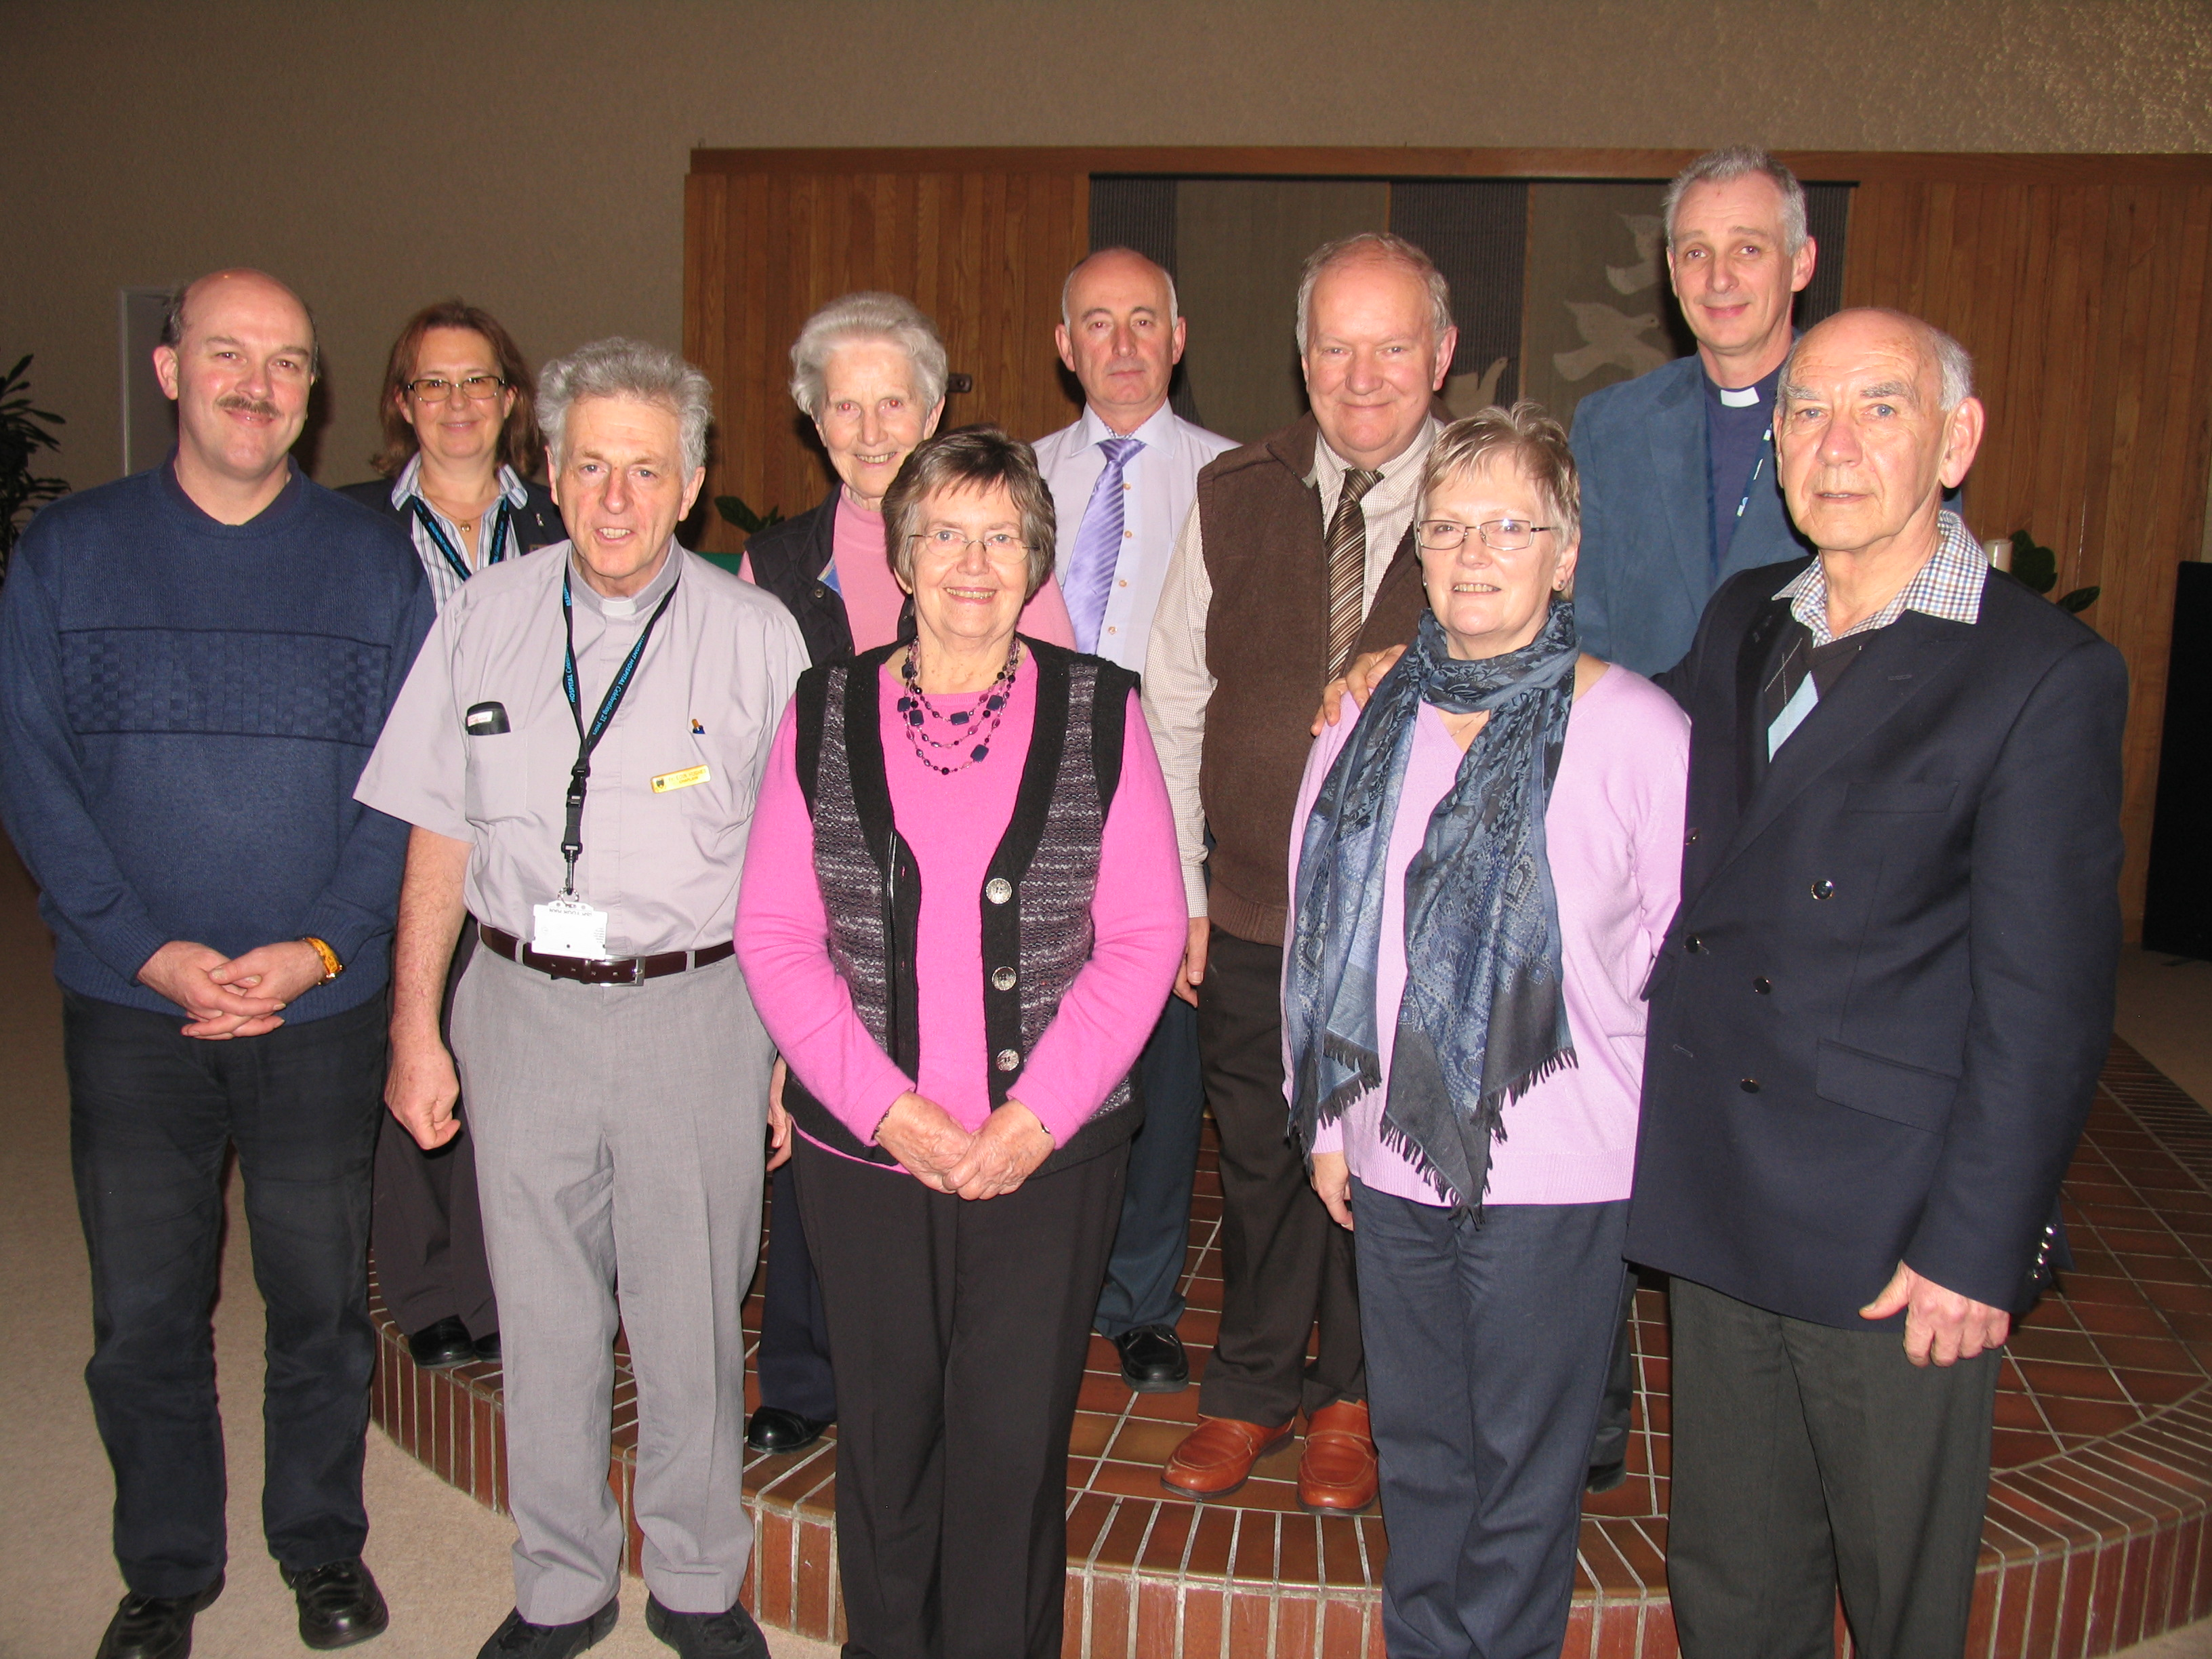

It was a very beneficial and enjoyable day.

Have you any stories you would like to share? Forward them to me any time.
................................................

God bless,

Derek

