NI Healthcare Chaplains’ Association

Supporting & Equipping Chaplains


"I was sick & you visited me"

E-newsletter January 2014: Edition 25

Please print out and display for colleagues

Feb training:
Reminder of notification sent out last week about training days at Dromantine, Newry, from 19th-20th Feb. All Wed overnight places & Thurs places are booked. There are a few Wed day places left.

CPE:
It is intended to run a further unit of CPE from Sept - Dec 2014. Priority will be given to applicants who are - (1) presently members of NIHCA & (2) practicing chaplains (whether paid or honorary). If places are available, others may apply but such applicants are liable to cover the cost of ACPE (I) accreditation (approx £600). If you are interested please get in touch with me asap.

Congratulations to Jim, Myriam, Joanne, Louise, John & Vivienne (pictured below with Sr Mary Jo Corcoran at CPE Graduation service 6/12/13) who completed the most recent unit.

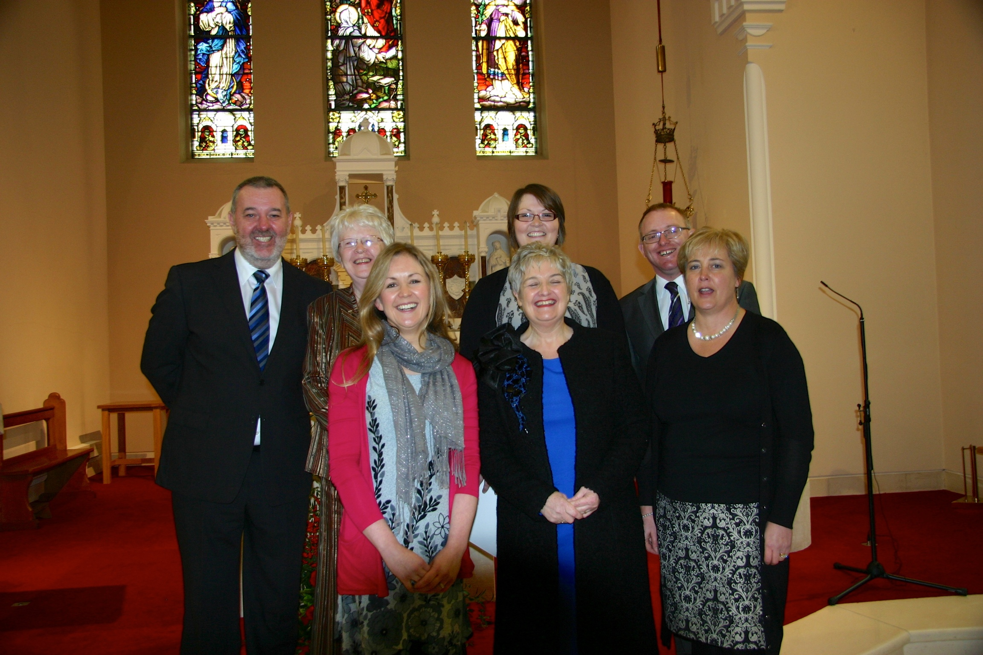

Refresher days:
It has been agreed that in 2015/16 there will be no CPE unit. Instead refresher days will be offered to previous CPE participants. These will be located across NI depending on participants. It is likely future NIHCA

programme will include the cycle of CPE units for 3 years then refresher days in the 4th year.

Ordination:
Congratulations to Brendan Collins (CPE 2011 - 2nd from right, with Conor McGrath, Angela Burke, Mary Jo Corcoran & Patrick Lagan) who was recently ordained.

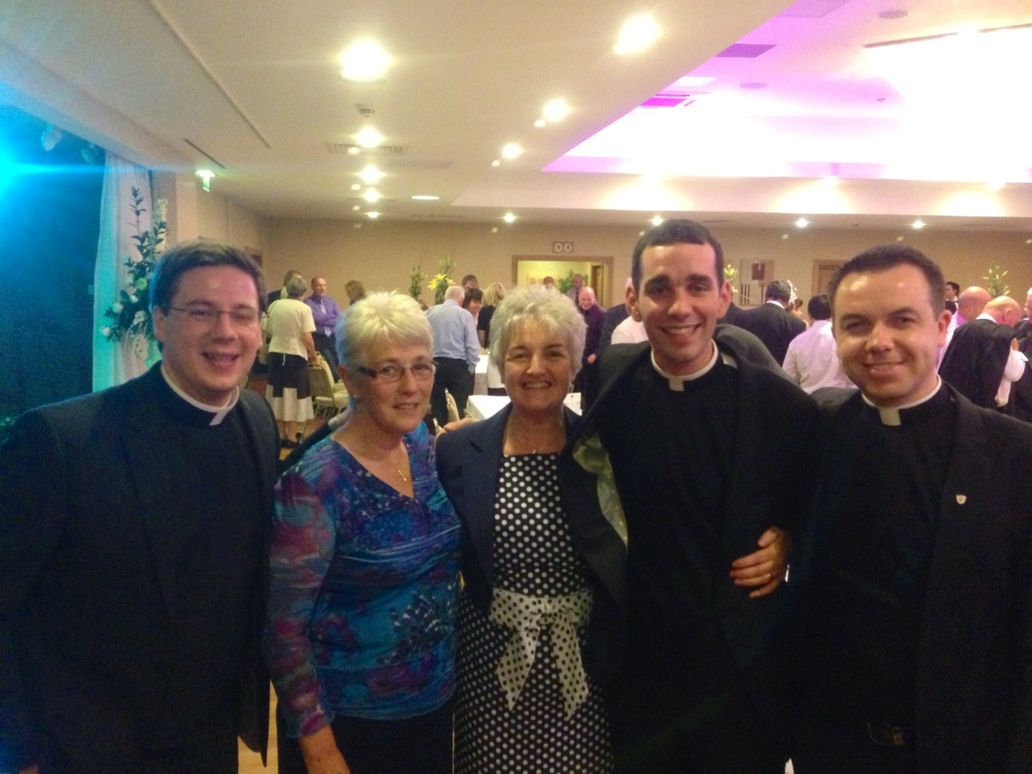

South Eastern Trust:
Congratulations also to Don Gamble who recently took up post as Lead Chaplain with the Trust.

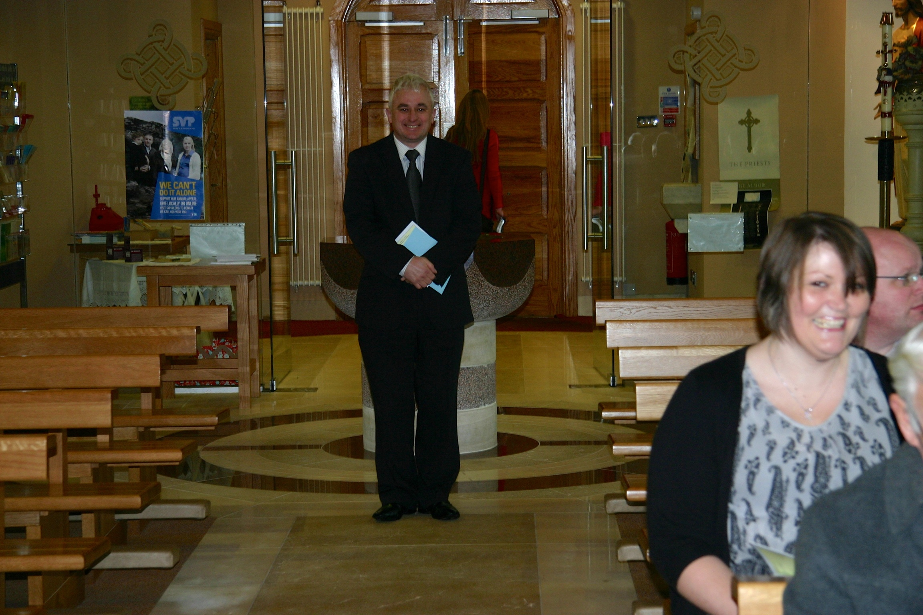

Flourish:
The Protect Life: Northern Ireland Suicide Prevention Strategy 2012-2014 highlights the fact that: ‘clergy generally lack any training as part of ministry for dealing with mental illness & suicide & have little awareness of advice & support services for mental health problems
experienced by congregation members & others.’ This strategy also refers to the fact that clergy indicated that: ‘they would benefit by attending training on mental illness & suicide but are concerned about peer-perceptions of inadequacy, perceived hostility from secular organisations & lack of time for these activities.’

In 2011 representatives from Lighthouse Ireland and the Churches Community Work Alliance approached clergy from across the four main churches to discuss a collaborative approach between Health and Social Care Trust, Churches and other suicide prevention and support agencies to providing support for families affected by mental health and suicide.
A working Group was set up in 2012 to explore ideas for a joint churches’ initiative on suicide and a process of consultation began between HSC, PHA, churches, faith based groups and community groups. Following this consultation guidelines for clergy were developed to include: Training pathway for clergy/church leaders, joint Family Support activities, introducing a Church Sunday to raise awareness of suicide and organising an Annual Joint Service of Reflection for families affected by suicide.

In 2013 the working group met with the leaders of the four main denominations in Ireland who fully endorsed the initiative. In a statement they said ‘Churches are at the forefront in caring for families and communities who have been affected by the suicide of a loved one. This support, which takes many forms, is long term and holistic. The project aims to enhance this support through training, awareness raising and helpful liturgical initiatives…it has the potential to make an important contribution to the care of many in our society.’

During 2013 resources (Guidelines, Training Pathway, Website www.wewillflourish.com) were developed and tested by focus groups from across the five Health Trust regions. The Training Pathway includes: Mood Matters, Faith and Mental Health, SafeTALK, Pastoral Support, Understanding Self-Harm, Bereavement Awareness, Applied Suicide

Intervention Skills Training (ASIST), Selfcare, Mental Health First Aid (MHFA) and specialised training where necessary. It is planned to pilot training in relation to faith and mental health and pastoral support in January/February 2014 and planning is at an advanced stage to develop a Mental Health Sunday. All of the training modules adhere to the Public Health Agency Standards for Quality Training in Northern Ireland (RSQTni) – Mental & Emotional Wellbeing & Suicide Prevention.

‘Flourish!’ is a Churches’ Initiative on Suicide developed by the Churches’ Community Work Alliance NI, Lighthouse Ireland and clergy from across the Christian churches in Northern Ireland in partnership with the Public Health Agency. Its aim is to support churches in addressing the needs of people affected by suicide and its objectives are to support churches to develop a focussed and shared approach to addressing the needs of people affected by suicide; To develop and provide appropriate training and good practice guidelines for clergy/church leaders/pastoral teams; To raise awareness of suicide prevention and support services through churches; To work together and with other agencies to increase access to support services for families recently bereaved by suicide; To develop and offer appropriate opportunities for reflection and remembrance for people bereaved by suicide; To support churches to work collaboratively with other groups and agencies on the issue of suicide.
If you require any further information relating to ‘Flourish!’ please direct your enquires to info@wewillflourish.com

It is planned to include some of the training topics offered by Flourish as part of NIHCA programme in 2014/15.

NIHCA AGM:
Fri 16th May 9.30 - 4.00pm at South West Acute Hospital (SWAH) Enniskillen
Morning - Standards, Competencies & Code of Conduct - Rev Dr Derek Fraser (Chair UKBHC); Afternoon - AGM

Official notification will be sent out in March/April.
........................................................

email - chaplains@nihca.co.uk
www.nihca.co.uk

God bless, Derek

